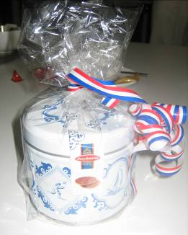
Report of the exchange meeting in Utrecht, the Netherlands
(3rd of June 2011)
We started the meeting on Friday morning with a short round to give everybody the opportunity to quickly introduce him- or herself. The group consisted of two partners and two older learners from Scotland, four partners and four learners from England, two partners and one learner from Germany and two partners and ten learners from the Netherlands. After this followed a brief presentation by Jessica van den Toorn of the Verwey-Jonker Institute about the broader project in which this meetin g took place: Older People and Technological innovations (OPT-in).
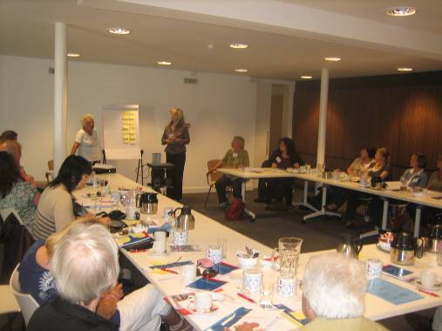
At the end of the presentation she asked everybody to discuss in couples what they hoped to learn/get from the meeting and what they hoped to teach/bring others. The couples presented these ideas on yellow papers in front of the group. The table below summarizes the answers. The exercise resulted in a nice discussion in which already learners and partners learned from each others examples.

Learn/get | Teach/bring
Exchange of knowledge and experience | How to use technology to learn more about your family history
Learn more about and play with the Kinect | How to use Picasa for photos
Inspiration | Ideas for new research projects regarding ageing and technology
A nice day | Pleasure
New friendships
To better understand how and where technologies can help | Expertise on the subject of older people and technology
Meeting and interaction with older people from other countries | Technology is fun
Listen to other people experience | Tell about my experiences: todays technology goes too fast. There is need for a basic computer. As people get older it becomes more difficult to learn new things
More knowledge about assistive technologies | Keep on moving on with new technology in body and soul also after retiring
Learn what older people like | Demonstration of the Kinect
New experiences about the use of technology by older people | Experience of working with older people and in encouraging exercise and activities
How can you influence the politics/policy makers to implement ICT in the life of older people? | Hand-held technologies
Feedback of older learners on different types of new technologies | Thoughts on future ways of using technology
Learn more about Tele-care | How senior students at the TU-Dortmund learn to work with computer programs
How do you motivate older people to learn about new technologies?
Ways/methods other countries use to make people familiar with modern technologies
Playing
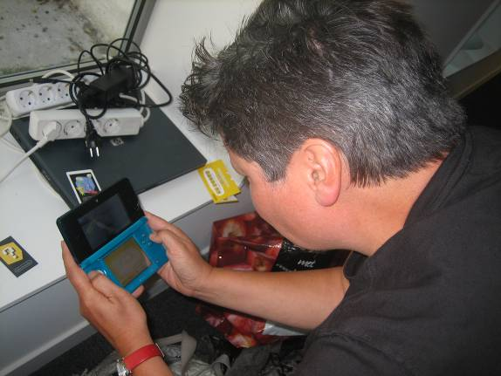
After the introductory meeting the learners could interact with all kinds of new technologies. The Kinect was introduced by Pim van den Toorn and the partners from England brought an I-pad, an e-reader and a Nintendo 3DS.

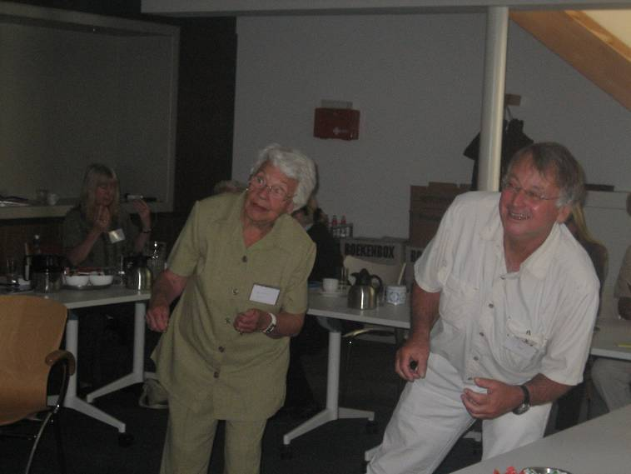

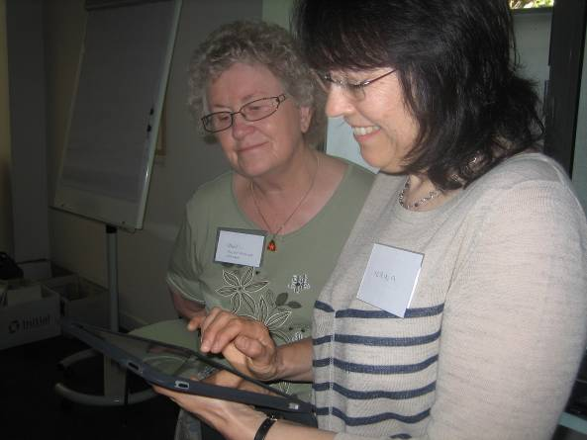

Lunch
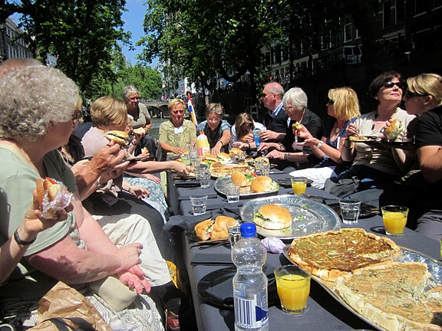
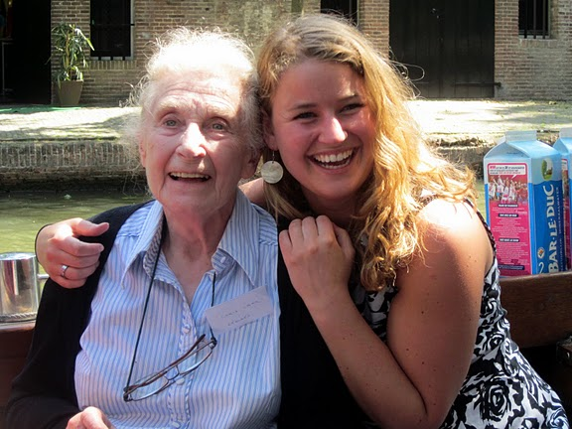
At 12.30 it was time for the lunch. The whole group went on a boot which took us through the canals of Utrecht. The great weather made the trip extra pleasant!
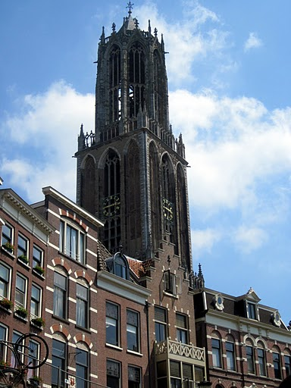
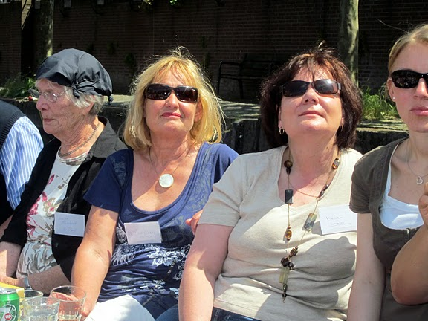
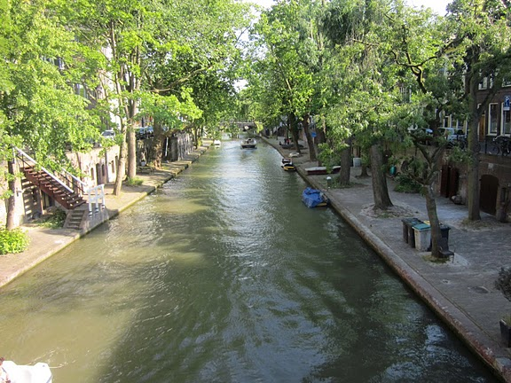

Museum ‘Speelklok’
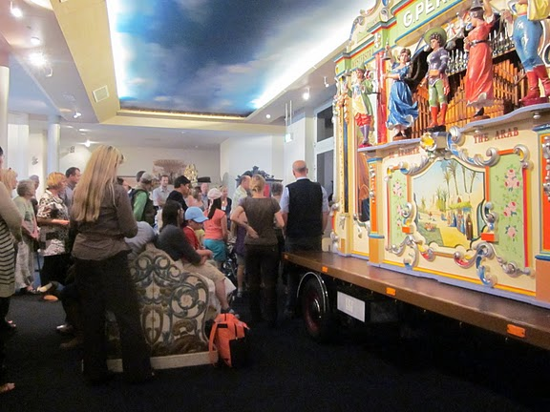
After the lunch we went to museum ‘Speelklok’. Here we learned how ‘old’ technology was used to produce nice music for social meetings. Carillon clocks, musical boxes, Flötenuhren, pianolas, the singing nightingale, orchestrions including the famous Violina, street, fairground and dance organs; Museum Speelklok (before: the National Museum ‘From Musical Clock to Street Organ’) has it all.
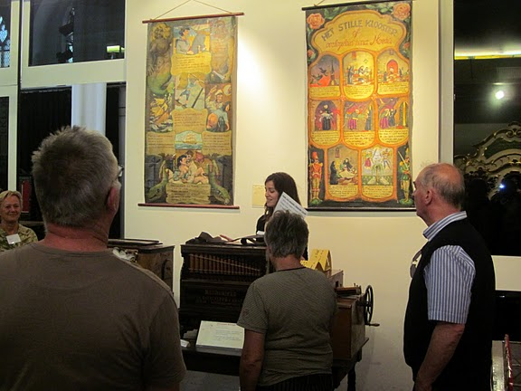

Diner
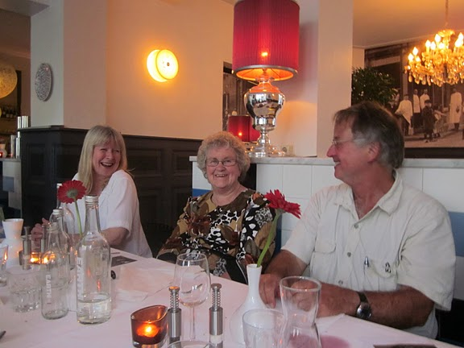
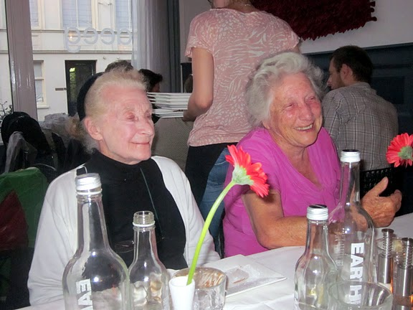
The day ended in the nice restaurant called ‘DEEG’.


